Name of Disease | Nervous or Endocrine System | Identifying images | Symptoms | Treatments
Goitre | Endocrine System | 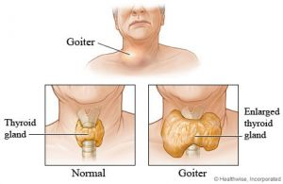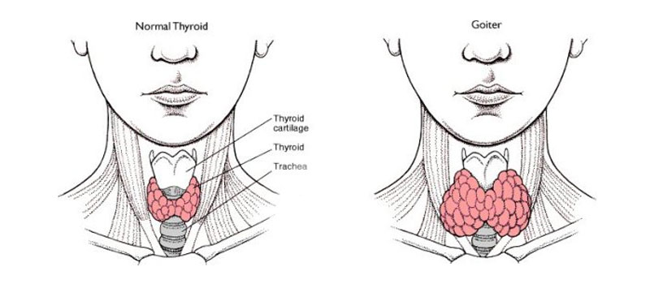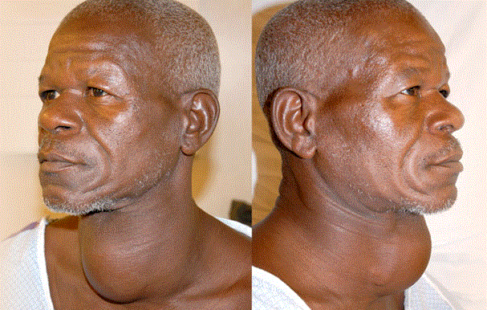 | Symptoms include:  Enlargement of the throat, ranging from a small lump to a huge mass.  Swallowing problems, if the goitre is large enough to press on the oesophagus.  Breathing problems, if the goitre is large enough to press on the trachea. | Treatments include:  Treatment depends on the underlying cause:  Goitre caused by iodine deficiency - can be helped with the introduction of iodine-rich foods into the diet, such as seafood and iodised salt.  Hyperthyroidism - is managed with drugs that slow the activity of the thyroid. If these fail to work, part or all of the thyroid gland is surgically removed. Alternatively, some or all of the thyroid’s hormone-producing cells can be destroyed with radioactive iodine treatment.  Hypothyroidism - is treated by lifelong hormone replacement therapy.  Benign thyroid nodules - are shrunk with medications, destroyed with radioactive iodine treatment or surgically removed, depending on the type.  Cancer of the thyroid - is treated by surgical removal of the gland, followed by radioactive iodine treatment.
Cushings Syndrome | Endocrine System | 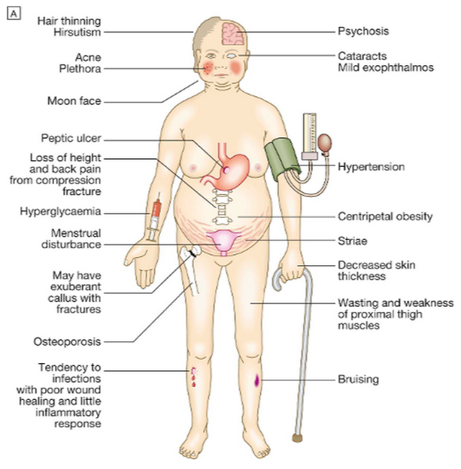  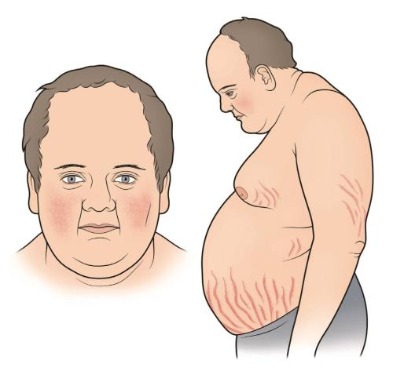  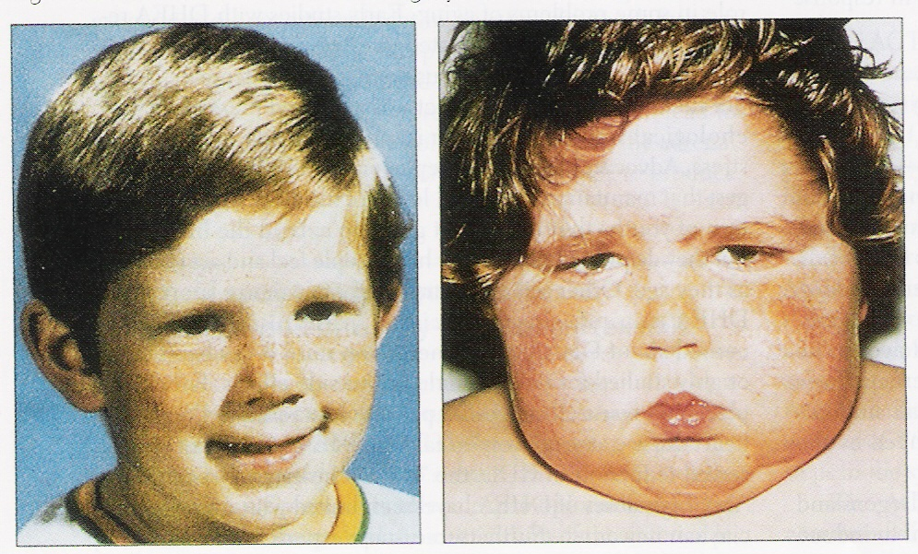 | Symptoms include:  There are many different symptoms of this condition, the most common of which are:  - Weight gain, obesity  - Fatty deposits,  - Stretch marks on the breasts, arms, abdomen, and thighs  - Thinning skin that bruises easily  - Cuts, insect bites, and Infections that are slow to heal  - Acne  - Fatigue  - Muscle weakness  - Glucose intolerance  - Increased thirst  - Increased urination  - Bone loss  - High blood pressure  - Headache  - Cognitive dysfunction  - Anxiety, irritability  - Depression  Women may also notice extra facial and body hair, as well as absent or irregular menstruation.  Men may also have:  erectile dysfunction  loss of sexual interest  decreased fertility  Children with this cause are generally obese and have a slower rate of growth. | Treatments include:  - Medication  - Radiation therapy  - Surgery  Although treatment will depend on what is causing the problem. Your doctor may prescribe a medication to help control cortisol production and ease symptoms.
Prolactinoma | Nervous System | 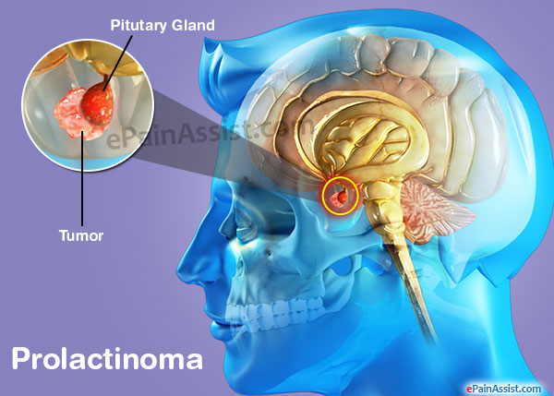  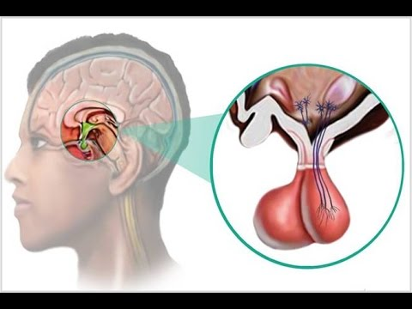  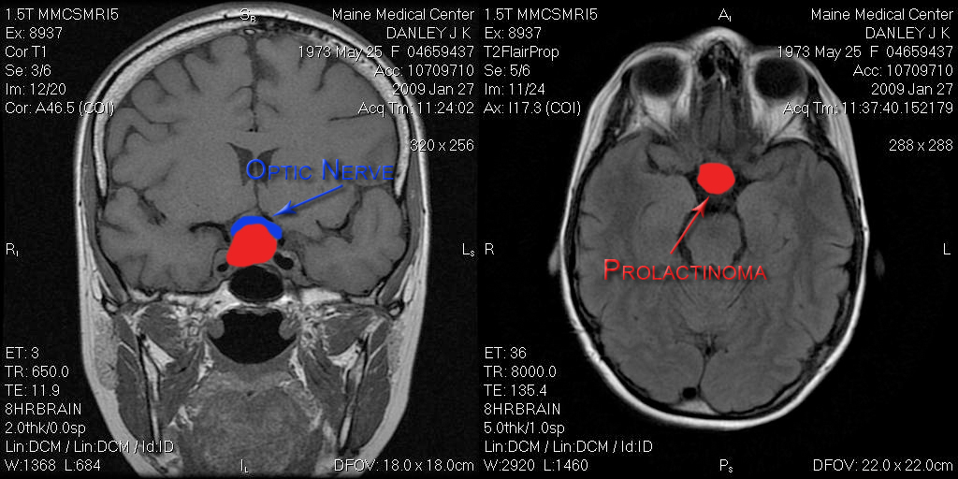 | Symptoms include:  In women:  - Abnormal milk flow from the breast in a woman who is not pregnant or nursing (galactorrhea)  - Breast tenderness  - Decreased sexual interest  - Decreased peripheral vision  - Headache  - Infertility  - Stopping of menstruation not related to menopause, or irregular menstruation  - Vision changes  In men:  - Decreased sexual interest  - Decreased peripheral vision  - Enlargement of breast tissue (gynecomastia)  - Headache  - Impotence  - Infertility  - Vision changes  Symptoms caused by pressure from a larger tumor may include:  - Headache  - Lethargy  - Nasal drainage  - Nausea and vomiting  - Problems with the sense of smell  - Vision changes, such as double vision, drooping eyelids or visual field loss  There may be no symptoms, especially in men. | Treatments include:  Medicine is usually successful in treating prolactinoma. Some people have to take these medicines for life. Some people can stop taking them, especially if their tumor has disappeared from the MRI. But there is a risk that the tumor may grow and produce prolactin again, especially if it is a large tumor.  A large prolactinoma can sometimes get larger during pregnancy.  Surgery is done in some cases when symptoms are severe such as sudden worsening of vision.  Radiation is usually only used in patients with prolactinoma that continues to grow or gets worse after both medication and surgery
Guillain Barre’ Disease | Nervous system. | 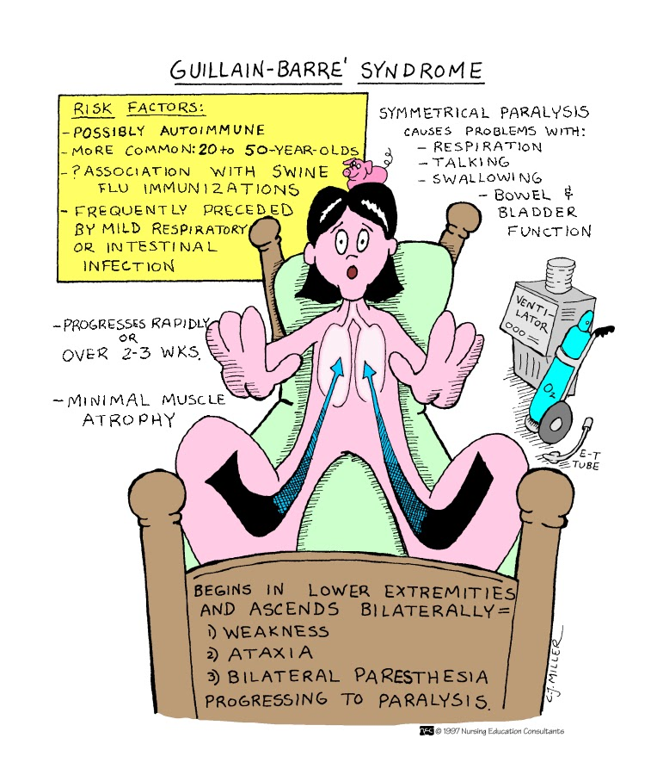  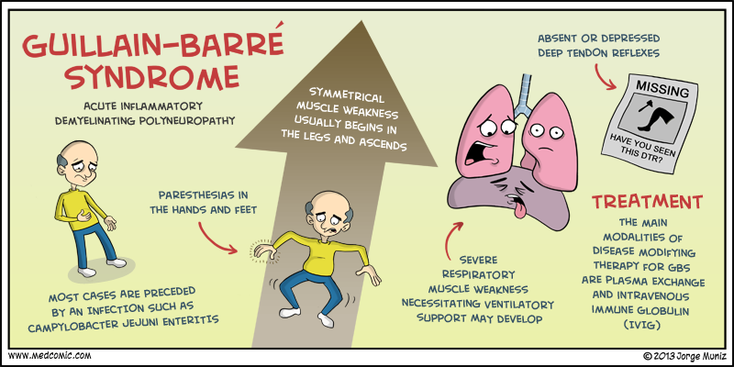 | Symptoms include:  - muscle weakness and paralysis affecting both sides of the body  - jerky, uncoordinated movements  - numbness  - muscle aches, pains or cramps  - odd sensations such as vibrations, buzzing or ‘crawling’ under the skin  - blurred vision  - dizziness  - breathing problems. | Treatments include:  There is no cure, but treatment options include:  - Plasmapheresis – blood is taken from the person. The immune cells are removed, and the remaining red blood cells are returned to the body.  - Gammaglobulin (IVIG) – trials have proven the effectiveness of this form of treatment. IVIG is given by infusion into a vein, usually every day for five days. Each infusion takes about two hours.
Multiple Sclerosis | Nervous System | 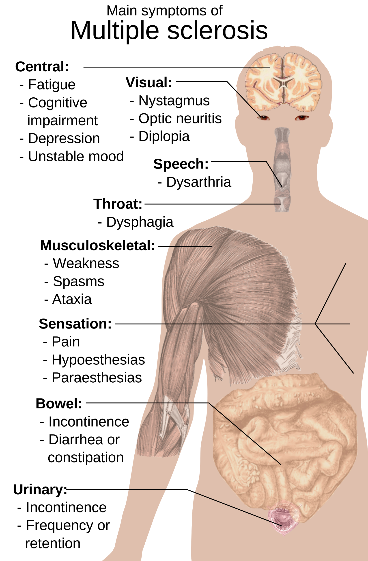  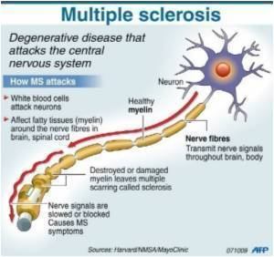 | Symptoms include:  - Fatigue – including heat sensitivity  - Other neurological symptoms – including vertigo, pins and needles, neuralgia and visual disturbances  - Continence problems – including bladder incontinence and constipation  - Neuropsychological symptoms – including memory loss, depression and cognitive (thought-related) difficulties. | Treatments include:  Muscle problems – a combination of medications may ease muscle problems, including stiffness and tremors. Physiotherapy is also recommended  - Fatigue – some studies have found that medications used to treat the sleep disorder narcolepsy are helpful in controlling MS-related fatigue  - Neurological symptoms – visual disturbances can be helped with medications, including steroids  - Continence – treatment for continence problems may include special exercises, medications, continence aids (such as disposable pads) and certain dietary changes  - Neuropsychological problems – treatment for depression or anxiety may include counselling or medication. Memory problems and other cognitive difficulties can be better managed with professional help from a neuropsychologist.
Paralytic Shellfish Poisoning | Nervous system | 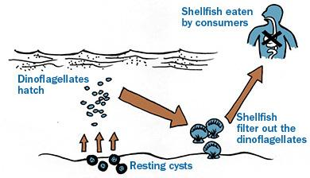  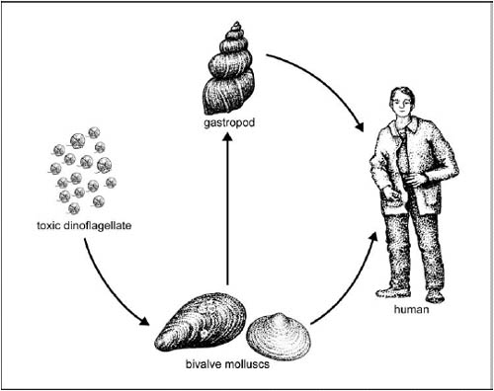 | Symptoms include:  - Coordination loss  - Speech defects  - nausea, vomiting  - death. | Treatments include:  There is no medication available. The only treatment for severe cases is the use of a mechanical respirator and oxygen.
Amyotrophic lateral Sclerosis | Nervous System | 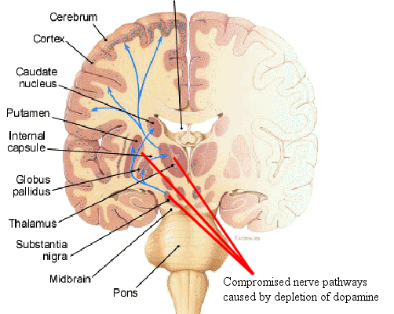  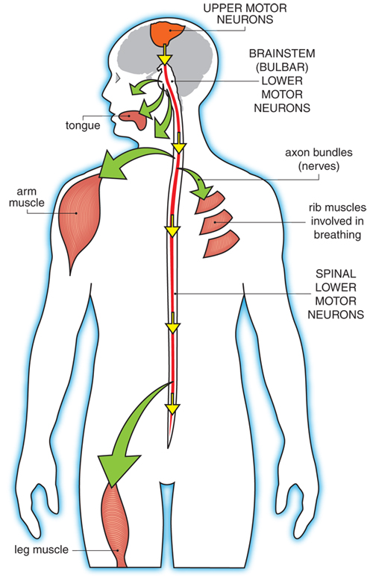 | Symptoms include:  - Having difficulties walking or doing normal day activities.  - Weaknesses in your legs, feet and ankles.  - Hand weaknesses.  - Slurring of speech or trouble swallowing.  - Muscle cramps.  - Twitching in your arms, shoulders and tongue.  - Difficulty keeping your head up or keeping a good posture. | Treatments include:  - Medications:  Doctors may prescribe to relief from symptoms such as…  - Muscle cramps and spasms  - Spasticity  - Constipation  - Fatigue  - Excessive salivation  - Excessive phlegm  - Pain  - Depression  - Sleep problems  - Uncontrolled outbursts of laughing or crying
Meningitis | Nervous System | 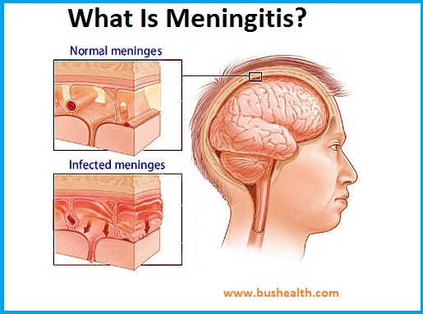  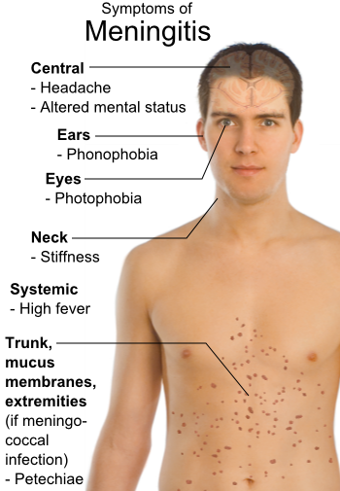 | Symptoms include:  A baby or young child with meningitis may:  - have a high fever, with cold hands and feet  - vomit and refuse to feed  - feel agitated and not want to be picked up  - become drowsy, floppy and unresponsive  - grunt or breathe rapidly  - have an unusual high-pitched or moaning cry.  In adults:  - Headache  - Altered mental status  - Ears:Phonophobia.  - Eyes:Photophobia.  - Stiffness in the neck  - High fever | Treatments include:  Bacterial Meningitis:  It must be treated immediately with intravenous antibiotics. This helps to ensure recovery and reduce the risk of complications, such as brain swelling and seizures.  Viral Meningitis:  Antibiotics can’t cure viral meningitis although there are some treatments such as  - Bed rest  - Plenty of fluids  - Pain medications to help reduce fever and relieve body aches.
Stroke | Endocrine System | 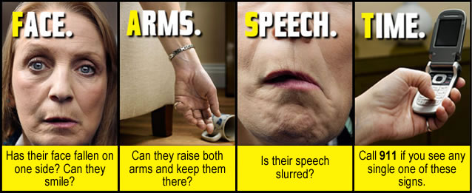  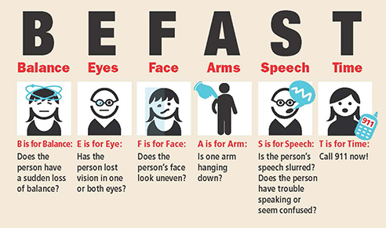  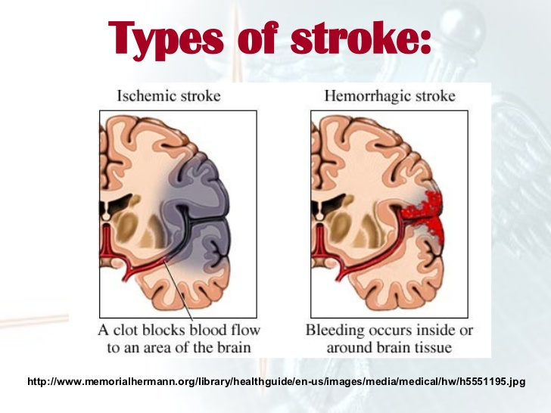 | Symptoms include:  - Sudden numbness or weakness of the face, arm or leg, especially on one side of the body  - Sudden confusion, trouble speaking or understanding  - Sudden trouble seeing or blurred vision in one or both eyes  - Sudden trouble walking, dizziness, loss of balance or coordination  - Sudden severe headache with no known cause | Treatments include:  - Medication  - Therapy  - Physio (some may need to learn how to eat, talk and walk through a stroke.)  - Surgery
Graves Disorder | Nervous System | 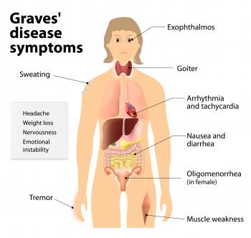  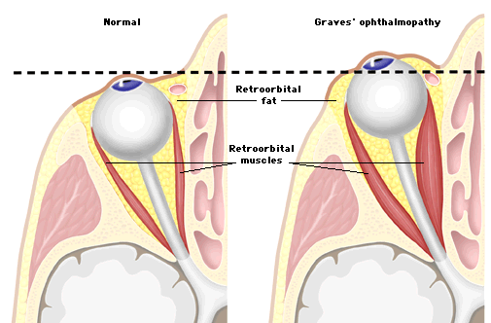  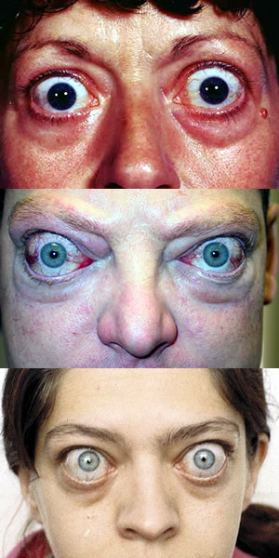 | Symptoms include:  - Sweating  - Muscle weakness  - Tremor  - Headache  - Weight loss  - Nervousness  - Anxiety,  - Heat sensitivity,  - Changes in menstrual cycles.  - Frequent bowel movements.  - Exophthalmos | Treatments include:  - Radioiodine therapy.  - Antithyroid drugs.  - Thyroid surgery.  - Surgery
Gigantism | Nervous System | 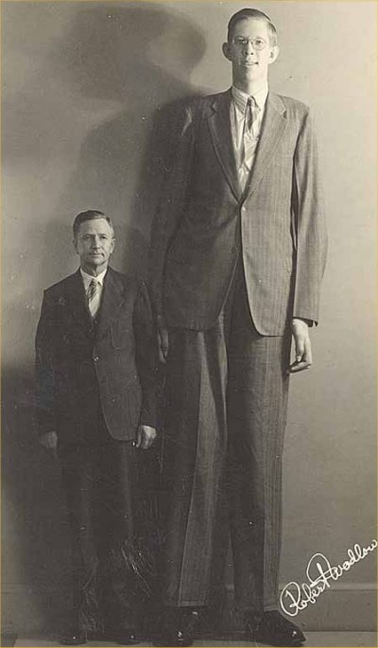   | Symptoms include:  - Excessive sweating  - Severe or recurrent headaches  - Weakness  - Insomnia and other sleep disorders  - Delayed puberty in both boys and girls  - Irregular menstrual cycle in girls  - Deafness | Treatments include:  - Surgery  - Medication  - Gamma Knife Radiosurgery
Cretinism | Endocrine System | 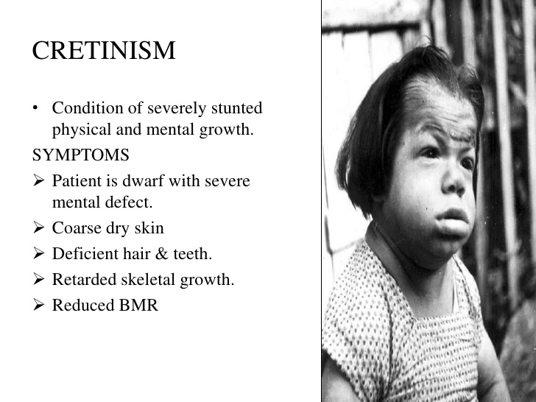  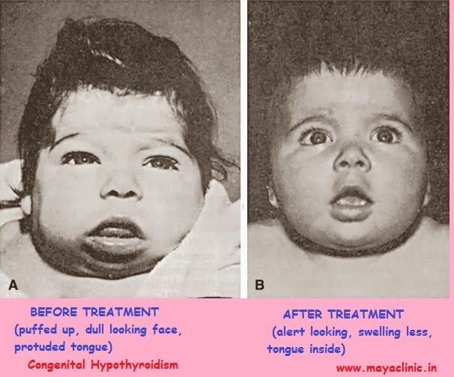  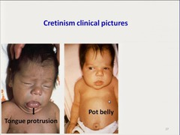 | Symptoms include:  - Floppy infant  - Thick, protruding tongue  - Poor feeding  - Choking episodes  - Constipation  - Prolonged jaundice  - Short stature  - Low hair line  - Short and wide face | Treatments include:  Cretinism is confirmed by tests, hormone replacement therapy is used in the form of oral thyroxine. The treatment should ideally be initiated within the first few weeks of life and continued throughout life. The doses should be increased or reduced whenever deemed as appropriate.

